**CI/CD PIPELINE USING JENKINS**

**SCOPE:**

To build a CI/CD pipeline using Jenkins

**PURPOSE:**

The main goal of a CI/CD pipeline using Jenkins is to streamline the software development and delivery process, making it more efficient, reliable, and responsive to changes in the codebase.

**TOOLS AND TECHNOLOGIES USED:**

1. **DOCKER:**

Docker is an open-source platform for building, shipping, and running containerized applications**.**

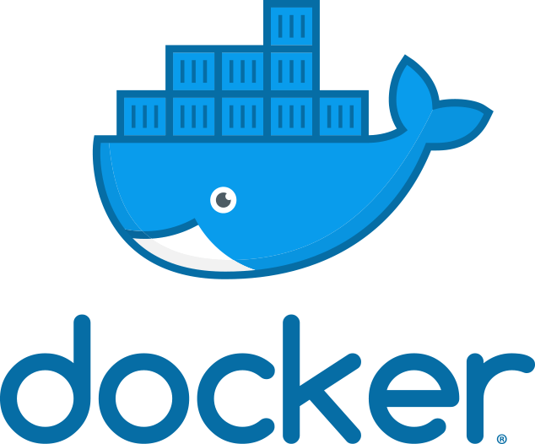

Docker has become a popular tool for application development and deployment, as it enables developers to package their applications into containers and deploy them to any platform that supports Docker, from local development environments to public clouds. It also provides a wide range of integrations and extensions, allowing users to customize and extend the platform as needed.

1. **GITHUB:**

GitHub is a web-based platform used for version control and collaboration on software development projects. It provides a central repository for code and allows developers to work together on projects, track changes to code over time, and collaborate on new features or bug fixes.



1. **JENKINS:**

Jenkins is an open-source automation tool written in Java with plugins built for continuous integration. Jenkins is used to build and test your software projects continuously making it easier for developers to integrate changes to the project, and making it easier for users to obtain a fresh build.

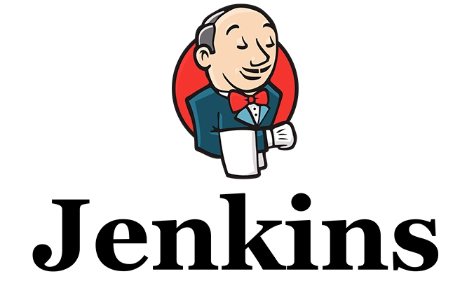

**4.SONARQUBE:**

SonarQube is a Code Quality Assurance tool that collects and analyzes source code, and provides reports for the code quality of your project. It combines static and dynamic analysis tools and enables quality to be measured continually over time.



**IMPLEMENTATION:**

Implementing a CI/CD pipeline involves setting up a series of steps to automate the process of building, testing, and deploying software applications.

Setting up a CI/CD pipeline using Jenkins requires careful consideration of system requirements to ensure smooth operation and efficient performance. Below are the typical system requirements for a Jenkins-based CI/CD pipeline:

**Hardware Requirements:**

**CPU**: Multi-core processor (e.g., 4 cores or more)

**RAM**: At least 8 GB of RAM (More RAM may be required depending on the complexity of your build and test processes)

**Disk Space**: Sufficient disk space to store Jenkins itself, plugins, build artifacts, and logs. A minimum of 50 GB is recommended, but this may vary depending on the scale of your projects.

**Operating System**:

Jenkins can run on various operating systems, including Windows, macOS, and Linux. Linux is often preferred for its stability and performance.

Java Runtime Environment (JRE):

Jenkins is built on Java, so you'll need a compatible JRE installed on your system. Jenkins typically requires Java 8 or higher.

**Steps:**

**Version Control System (VCS):**

Choose a version control system (e.g., Git) and set up a repository to host your project's codebase. Developers will commit their code changes to this repository.

**Continuous Integration (CI):**

Set up the CI part of the pipeline to automate the building and testing of your application whenever new code changes are pushed to the VCS.

**Jenkins Installation:**

Install Jenkins on a server or a cloud-based instance. You can follow the official Jenkins documentation for installation instructions.

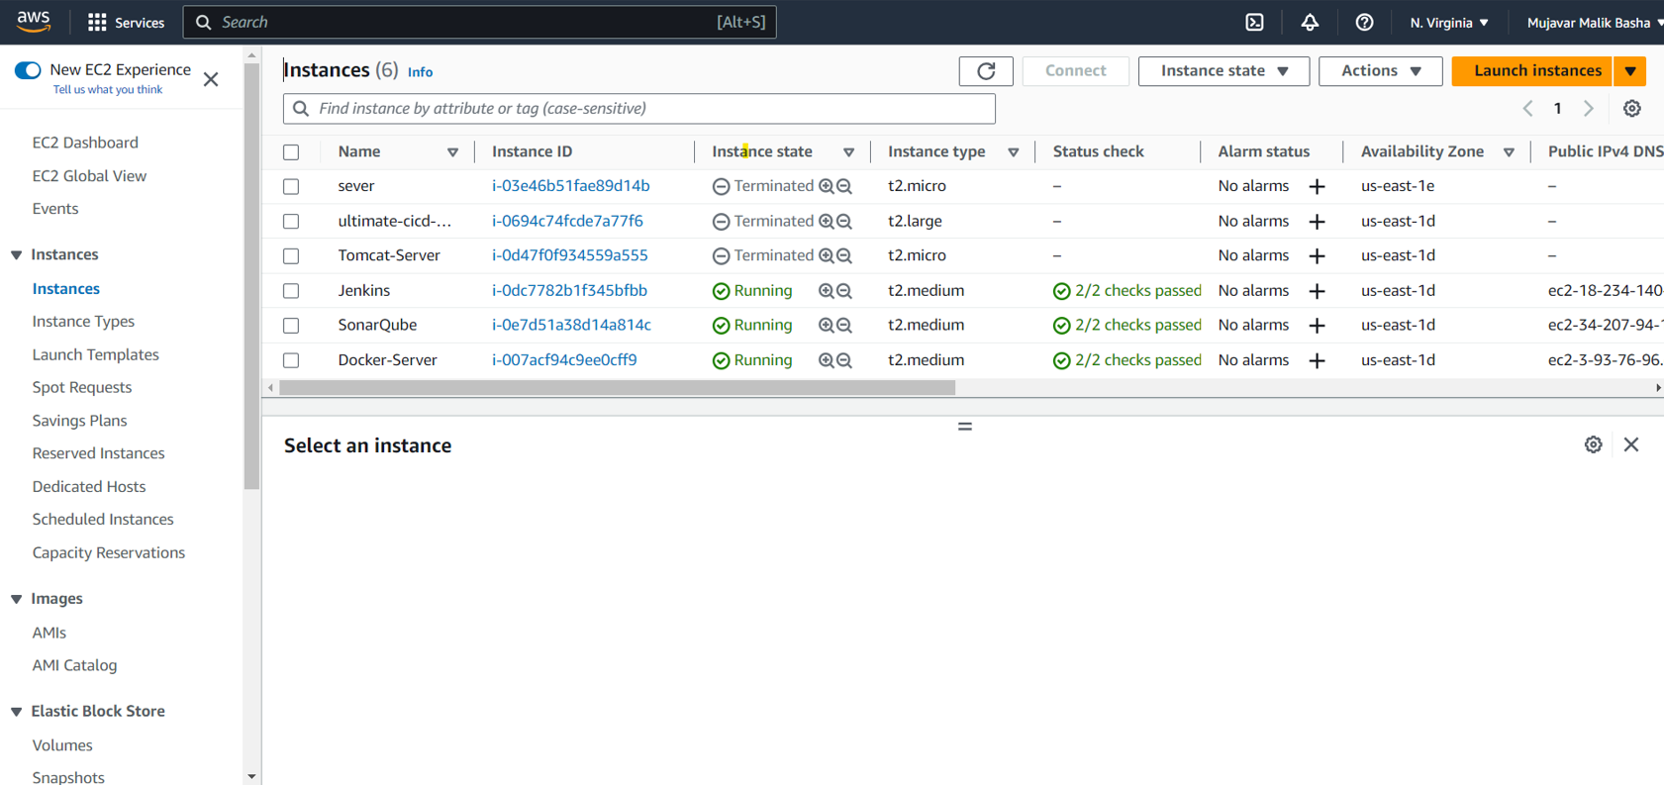

**Project Configuration:**

Create a new Jenkins project (freestyle, pipeline, or multibranch pipeline) that corresponds to your application.

**Source Code Management:**

Configure Jenkins to connect to your version control system and specify the repository URL.

**Build Triggers:**

Set up triggers to automatically start the build process whenever changes are detected in the repository (e.g., polling for changes or using webhooks).

**Build Step:**

Define the build step that fetches the latest code, compiles the application, and generates the required artifacts.

**Testing:**

Integrate automated testing into the pipeline. You can use testing frameworks and tools suitable for your application's technology stack.

**Artifacts:**

Store the generated artifacts (e.g., binary files, executable packages) for later stages.

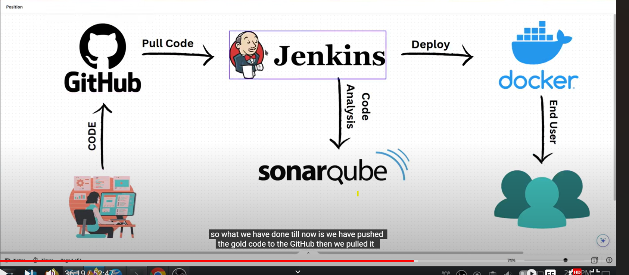

**Continuous Deployment (CD):**

Configure the CD part of the pipeline to automate the deployment of your application to various environments (e.g., staging, production) after successful testing.

**Environment Configuration:**

Set up the necessary environments where you want to deploy your application (e.g., staging, production servers).

**Deployment Step:**

Define the deployment step in your Jenkins pipeline that takes the tested artifacts and deploys them to the appropriate environment.

**Rollback Mechanism:**

Implement a rollback mechanism in case there are issues with the deployment.

**Monitoring and Notifications:**

Integrate monitoring tools to keep track of the application's performance and health in production. Set up notifications (e.g., email, Slack) to alert the team if something goes wrong.

**Pipeline Customization:**

Customize your CI/CD pipeline to suit your specific needs. You may need to add additional stages, integrate with other tools, or implement security measures like access controls and secrets management.

**Documentation and Training:**

Ensure that the CI/CD pipeline is well-documented, and provide training to team members on how to use and contribute to the pipeline effectively.

**Continuous Improvement:**

Regularly review and improve your CI/CD pipeline based on feedback, changing requirements, and new technologies.

**PROOF OF CONCEPT:**

So by using these Jenkins pipeline and with the help of the sonarqube which tested the vulnerability of the source code and finally we have deployed our source code and the Jenkins continuously tested the integrated changes and very responsive to the made changes.

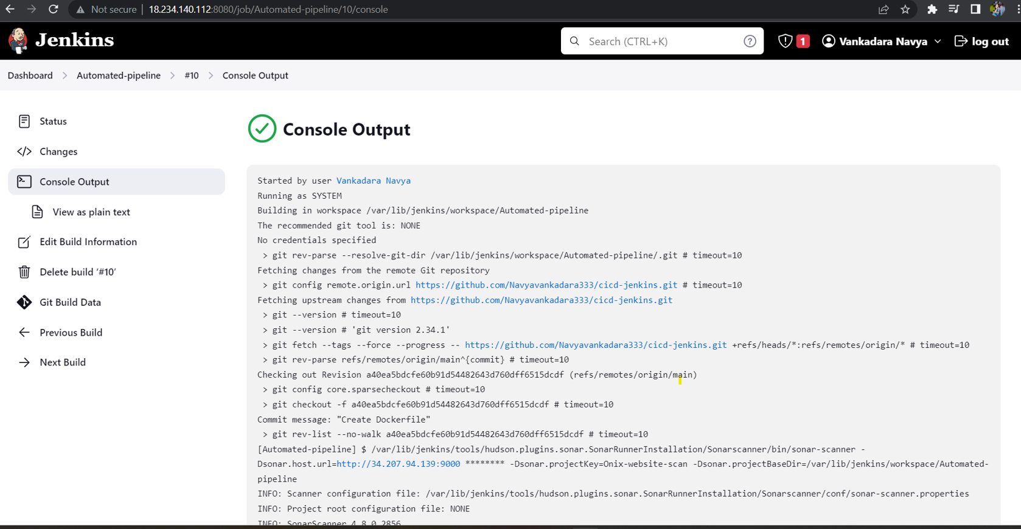

This sonarqube is a tool it analyzed our source code and provided a quality report.

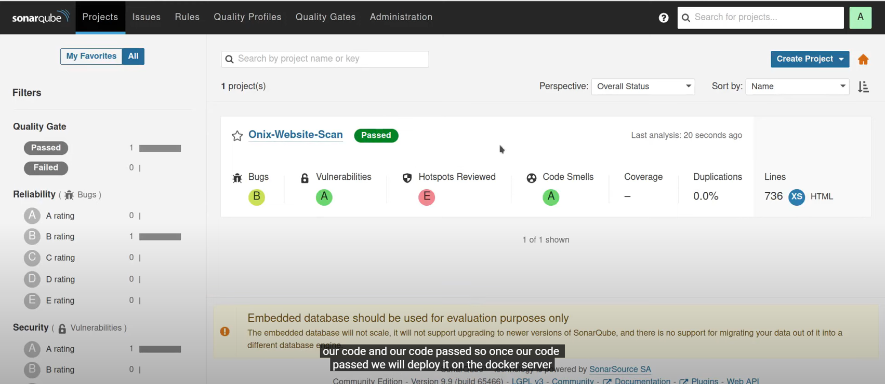

**OUTCOME:**

So this is the application which we have deployed using the Jenkins pipeline.



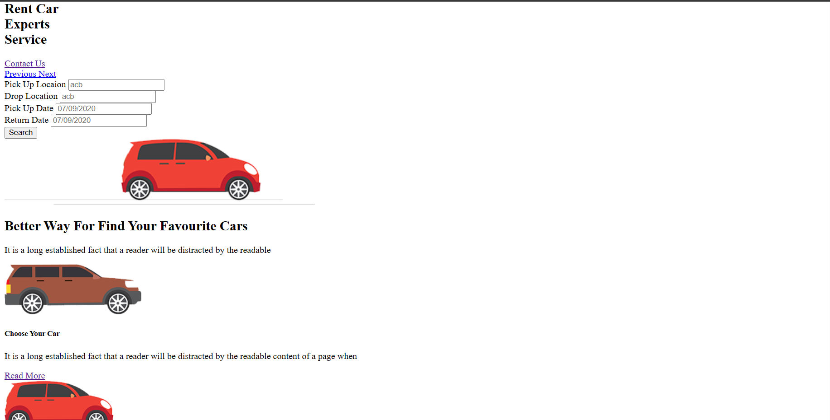

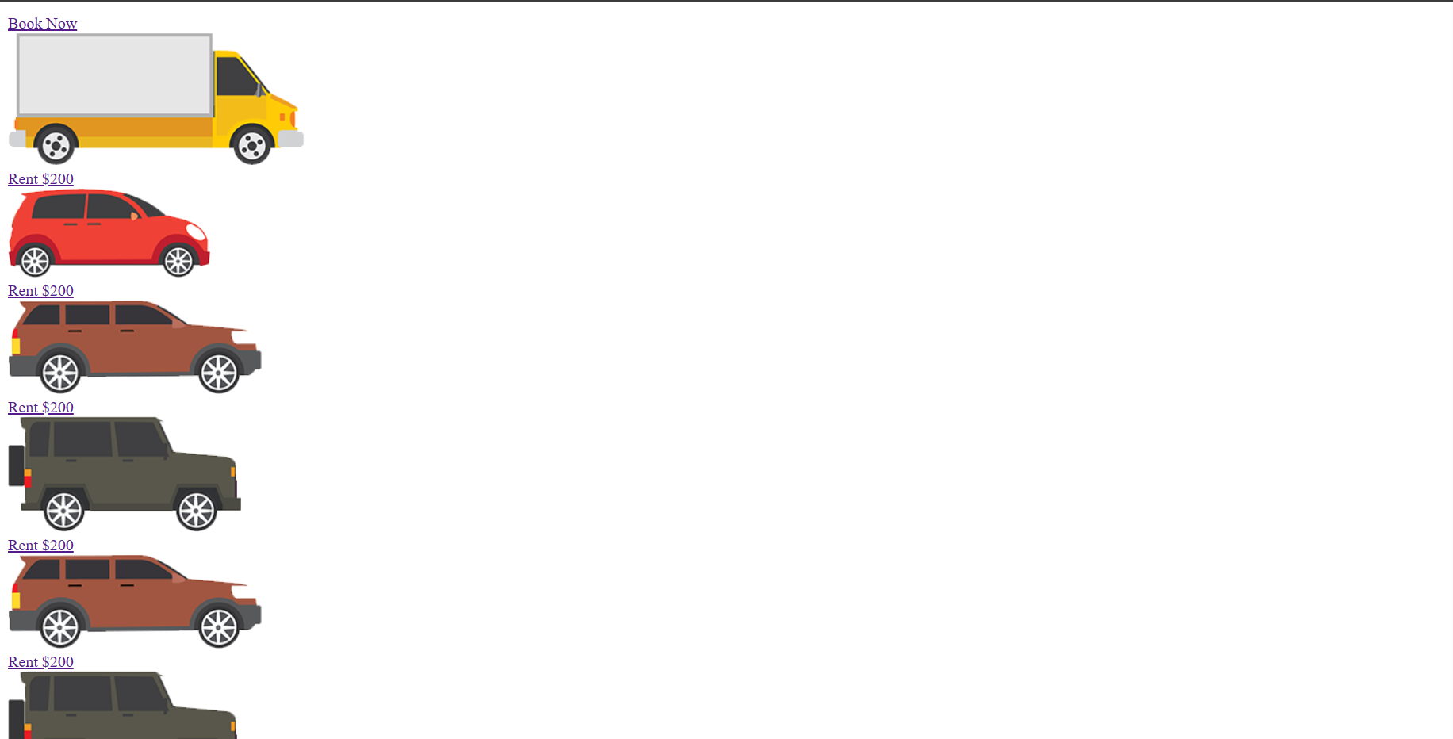



**CONCLUSION**:

In conclusion, implementing a CI/CD pipeline using Jenkins can provide many benefits, including improved scalability, reliability, and efficiency.

Jenkins has been successfully set up as a CI server, automating the build and testing process for the project. Developers can easily integrate their code changes into the main codebase, triggering automated builds and tests.

The CI/CD pipeline, coupled with SonarQube's feedback on code quality, has fostered a culture of continuous improvement. Developers receive immediate feedback on their changes, leading to better collaboration and knowledge sharing within the team.

With Docker containers, the application's deployment becomes scalable and reproducible across different environments. This reduces the risk of deployment-related issues and simplifies the process of scaling the application to handle increased loads.

In conclusion, the CI/CD pipeline project using Jenkins, SonarQube, and Docker has been a success. It has transformed the development and deployment processes, resulting in faster, more reliable, and higher-quality software delivery. The implementation of best practices for automation, testing, and code analysis has set the foundation for continuous improvement, enabling the team to respond quickly to changing requirements and deliver value to users efficiently.